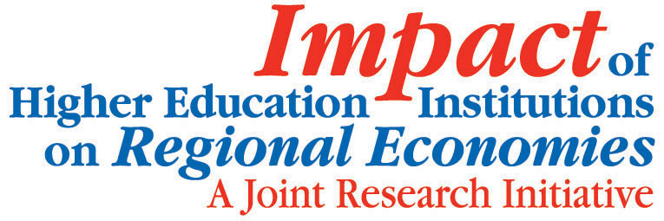
Universities and Economic Renewal – partnerships and progress for our future
Venue: The Japan Room
Wales Millennium Centre
Bute Place
Cardiff Bay
CF10 5AL
Wednesday 6th October 2010 9.30am – 13.00pm
COFFEE AND REGISTRATION: 9am – 10am
10am Welcome from the Chair
Professor Philip Gummett, HEFCW
10.05am Overview
Ursula Kelly, University of Strathclyde
Impact of Higher Education Institutions on Regional Economies Research Initiative Joint Coordinator.
This brief presentation will give an overview of the wide range of research being undertaken as part of the Impact of Higher Education Institutions on Regional Economies research venture.
10.15am The myth of the ivory tower: the connectivity of UK academia with the business, public and third sector
Michael Kitson, Cambridge University
COFFEE BREAK: 10.45am – 11.05am
11.05am The impact of University Engagement through Knowledge Transfer: Issue for Regional Economic Development
Robert Huggins, UWIC
11.35am The Impact of HEIs on the Welsh Economy
Peter McGregor, University of Strathclyde
12.05pm Panel Session
- Professor Philip Gummett (CEO, HEFCW)
- Gareth Hall (Welsh Assembly Government – Director of Department of Economy & Transport)
- Professor Richard Davies (Vice-Chancellor Swansea University – subject to confirmation)
- Welsh Business Sector Representative (tbc)
12.50pm Closing remarks
Professor Philip Gummett
Lunch: 13.00pm

